Replicated log

Iteration 0.

Choose a desirable language for implementation and try to implement (or find the implementation) a simple Echo Client-Server application.

Iteration 1.
- 10 points
The Replicated Log should have the following deployment architecture: one Master and any number of Secondaries.

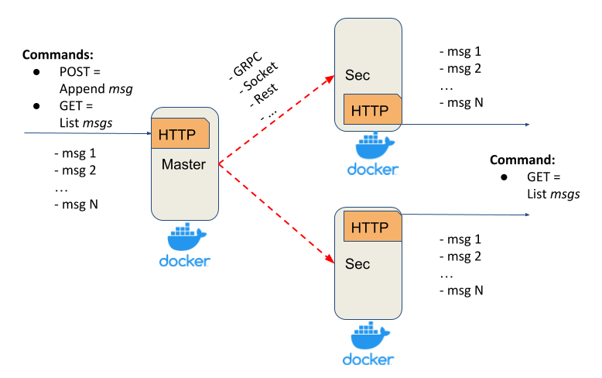
Master should expose a simple HTTP server (or alternative service with a similar API) with:
- POST method - appends a message to the in-memory list
- GET method - returns all messages from the in-memory list

Secondary should expose a simple HTTP server(or alternative service with a similar API) with:
- GET method - returns all replicated messages from the in-memory list

Properties and assumptions:
- after each POST request, the message should be replicated on every Secondary server
- Master should ensure that Secondaries have received a message via ACK
- Master’s POST request should be finished only after receiving ACKs from all Secondaries (blocking replication approach)
- to test that the replication is blocking, introduce a delay/sleep on the Secondary
- at this stage, assume that the communication channel is a perfect link (no failures and messages lost)
- any RPC framework can be used for Master-Secondary communication (Sockets, language-specific RPC, HTTP, Rest, gRPC, …)
- your implementation should support logging
- Master and Secondaries should run in Docker

Testing
To test the system behaviour under different network failures in a predictable manner, it is proposed to additionally implement a test harness.
It should allow simulating network failures programmatically and verifying the expected behaviour through integration tests.
In the current iteration, it should be tested that replication runs in parallel and that the master waits for ACKs from all secondaries.

Possible Hareness test can be represented in the following way:

transport = MockedTransport()
masterNode = MasterNode(transport)
secondaryNode1 = SecondaryNode(transport)
secondaryNode2 = SecondaryNode(transport)

transport.setDelay(masterNode, secondaryNode1, 5 sec)

masterNode.appendMsg("m1") <- should be blocked for 5 sec
masterNode.listMsgs() -> "m1"

transport.setDelay(masterNode, secondaryNode2, 6 sec)

masterNode.appendMsg("m2") <- should be blocked for 6 sec
masterNode.listMsgs() -> "m1", "m2"

transport.removeDelay(masterNode, secondaryNode1)
transport.removeDelay(masterNode, secondaryNode2)

masterNode.appendMsg("m3") <- no blocking

masterNode.listMsgs() -> "m1", "m2", "m3"
secondaryNode1.listMsgs() -> "m1", "m2", "m3"
secondaryNode2.listMsgs() -> "m1", "m2", "m3"

Iteration 2.
- 20 points
In the previous iteration, the replication was blocking for all secondaries, i.e. to return a response to the client, we should receive acknowledgements (ACK) from all secondaries.

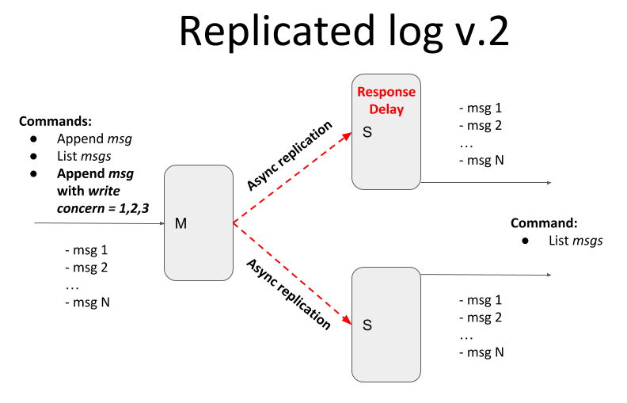

Current iteration should provide tunable semi-synchronicity for replication, by defining write concern parameters.
- client POST request in addition to the message should also contain write concern parameter w=1,2,3,..,n
- w value specifies how many ACKs the master should receive from secondaries before responding to the client
w = 1 - only from master
w = 2 - from master and one secondary
w = 3 - from master and two secondaries

Add logic for messages to guarantee the total ordering of messages.

Testing
- Using Test harness emulate replicas' inconsistency (and eventual consistency) with the master by introducing an artificial delay on the secondary node. In this case, the master and secondary should temporarily return different messages lists.

Acceptance test:
- Start M + S1 + S2 (delay 5-10 sec)
- send (Msg1, W=1) - Ok
- send (Msg2, W=2) - Ok
- send (Msg3, W=3) - Wait because of S2 replication delay
- send (Msg4, W=1) - Ok - should not be blocked by step 4 (the command may run in a different thread)
- Check messages on S2 - [Msg1, (Msg2), (Msg3)]
- Check messages on M|S1 - [Msg1, Msg2, Msg3, Msg4]

- Introducing new method into Test harness to emulate messages reordering

transport = MockedTransport()
masterNode = MasterNode(transport)
secondaryNode1 = SecondaryNode(transport)
secondaryNode2 = SecondaryNode(transport)

transport.reorderMessages(masterNode, secondaryNode1, messages_count = 2) <- should wait for N (2 by default) messages and reorder them

masterNode.appendMsg("m1")
masterNode.appendMsg("m2")

secondaryNode1.listMsgs() -> "m1", "m2" <- messages should be listed in a correct order

Iteration 3.
- 20 - 40 points
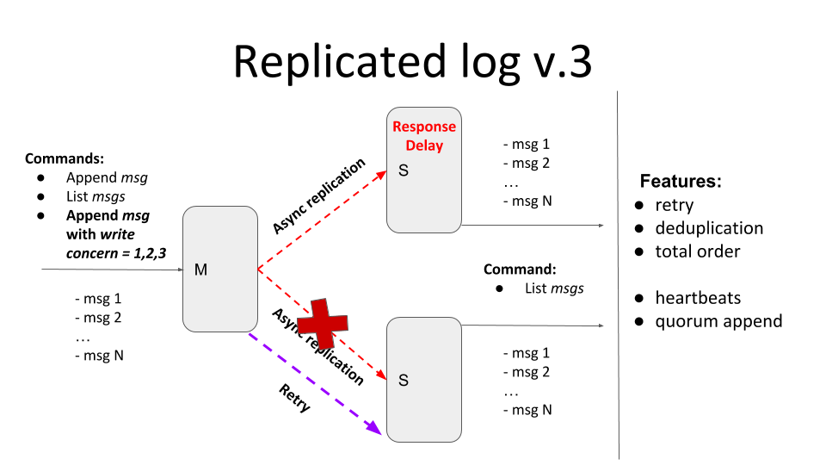

The current iteration should provide tunable semi-synchronicity for replication with a retry mechanism that should deliver all messages exactly-once in total order.

Main features (maximum 20 points):
- If message delivery fails (due to connection, or internal server error, or the secondary is unavailable), the delivery attempts should be repeated - retry
  - If one of the secondaries is down and w=3, the client should be blocked until the node becomes available. Clients running in parallel shouldn’t be blocked by the blocked one.
  - If w>1 the client should be blocked until the message is delivered to all secondaries required by the write concern level. Clients running in parallel shouldn’t be blocked by the blocked one.
  - All messages that secondaries have missed due to unavailability should be replicated after (re)joining the master
  - Retries can be implemented with an unlimited number of attempts but, possibly with some “smart” delay logic
  - You can specify a timeout for the master in case if there is no response from the secondary
- All messages should be present exactly once in the secondary log - deduplication
  - To test deduplication, you can generate a random internal server error response from the secondary after the message has been added to the log
- The order of messages should be the same in all nodes - total order
  - If secondary has received messages [msg1, msg2, msg4], it shouldn’t display the message ‘msg4’ until the ‘msg3’ will be received
  - To test the total order, you can generate a random internal server error response from the secondaries

Testing
TBD …

Self-check acceptance test:
- Start M + S1
- send (Msg1, W=1) - Ok
- send (Msg2, W=2) - Ok
- send (Msg3, W=3) - Wait
- send (Msg4, W=1) - Ok
- Start S2
- Check messages on S2 - [Msg1, Msg2, Msg3, Msg4]

Additional features:
- Heartbeats (+15 points)
You can implement a heartbeat mechanism to check secondaries’ health (status): Healthy -> Suspected -> Unhealthy.
They can help you to make your retries logic smarter.
You should have an API on the master to check the secondaries’ status: GET /health

- Quorum append (+5 points)
If there is no quorum, the master should be switched into read-only mode and shouldn’t accept messages append requests, and should return the appropriate message

